Kubernetes Taks-03
TASK 1 — Create a ClusterIP Service for an Apache Web Server Pod
Concept
ClusterIP is the default Kubernetes Service type.
It allows communication with the pod inside the Kubernetes cluster.
Architecture:
Client inside cluster
|
v
ClusterIP Service
|
v
Apache Pod

Step 1 — Create Apache Pod
Create the YAML:
vi apache-pod.yaml
Add:
apiVersion: v1
kind: Pod
metadata:
name: apache-pod
labels:
app: apache
spec:
containers:
- name: apache
image: httpd
ports:
- containerPort: 80
Save:
ESC
:wq
ENTER

Step 2 — Create Pod
kubectl apply -f apache-pod.yaml
Check:
kubectl get pods
Expected:
apache-pod 1/1 Running
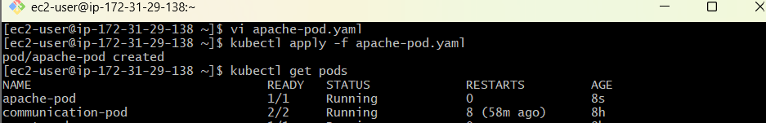

Step 3 — Create ClusterIP Service
Create:
vi apache-service.yaml
Add:
apiVersion: v1
kind: Service
metadata:
name: apache-service
spec:
type: ClusterIP
selector:
app: apache
ports:
- port: 80
targetPort: 80
Apply:
kubectl apply -f apache-service.yaml

Step 4 — Verify
kubectl get svc
You should see:
apache-service ClusterIP 10.x.x.x <none> 80/TCP
Check endpoints:
kubectl get endpoints apache-service
You should see the Apache pod IP.
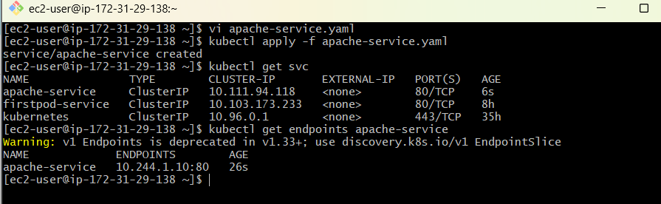

Step 5 — Test Apache
Create a temporary testing pod:
kubectl run test-pod --image=curlimages/curl -it --rm -- sh
Inside the container:
curl http://apache-service
You should receive Apache HTML output.
Exit:
exit
Cleanup
kubectl delete -f apache-pod.yaml
kubectl delete -f apache-service.yaml
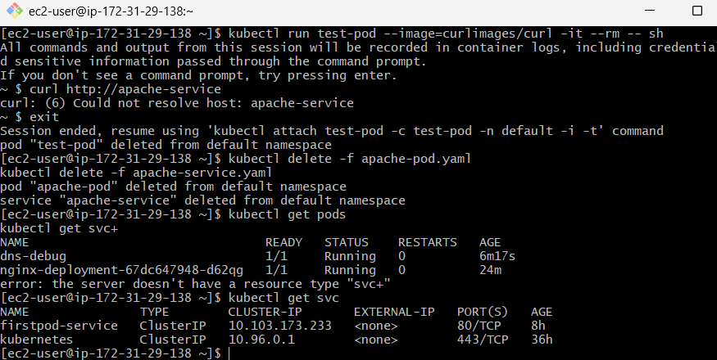

TASK 2 — Expose an Nginx Pod Externally Using NodePort
Now we'll expose Nginx outside the cluster.
Architecture:
Internet
|
v
EC2 Worker Node IP
|
NodePort :30080
|
v
Nginx Pod

Step 1 — Create Nginx Pod
vi nginx-nodeport.yaml
Add:
apiVersion: v1
kind: Pod
metadata:
name: nginx-nodeport
labels:
app: nginx-nodeport
spec:
containers:
- name: nginx
image: nginx
ports:
- containerPort: 80
Apply:
kubectl apply -f nginx-nodeport.yaml
Check:
kubectl get pods
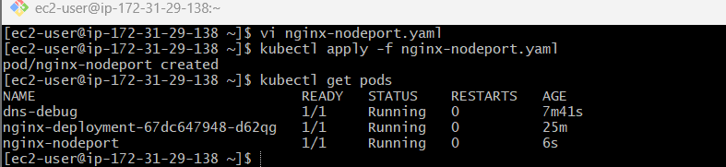

Step 2 — Create NodePort Service
vi nginx-nodeport-service.yaml
Add:
apiVersion: v1
kind: Service
metadata:
name: nginx-nodeport-service
spec:
type: NodePort
selector:
app: nginx-nodeport
ports:
- port: 80
targetPort: 80
nodePort: 30080
Apply:
kubectl apply -f nginx-nodeport-service.yaml

Step 3 — Verify
kubectl get svc
Expected:
nginx-nodeport-service NodePort ... 80:30080/TCP
The important part is:
30080
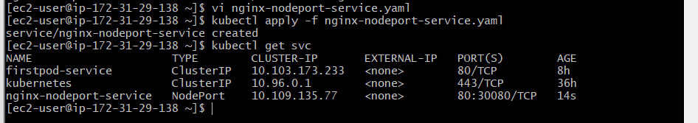

Step 4 — Get Worker Node IP
Run:
kubectl get nodes -o wide
Look for:
INTERNAL-IP
For example:
172.31.29.138
If you're accessing from your laptop, you generally need the EC2 public IP of a node and the AWS Security Group must allow TCP 30080.
Then:
http://<EC2-PUBLIC-IP>:30080
Example:
http://13.x.x.x:30080
You should see:
Welcome to nginx!
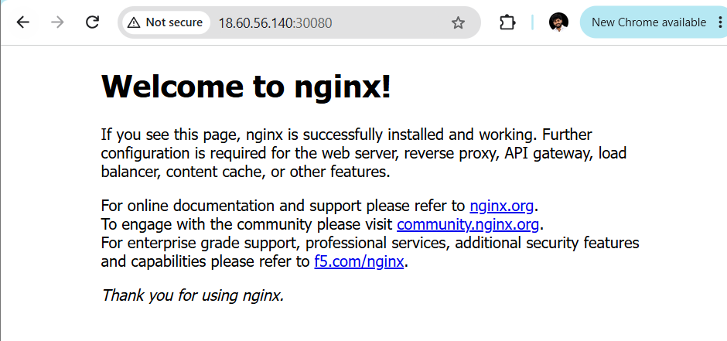

TASK 3 — ReplicationController with 3 Nginx Replicas
Now we'll create a ReplicationController.
Concept
ReplicationController maintains the required number of pods.
ReplicationController
|
+----+----+
| | |
Pod1 Pod2 Pod3
If one pod dies:
Pod1 ❌

ReplicationController
|
+----+----+
| | |
Pod2 Pod3 Pod4

Step 1 — Create YAML
vi nginx-rc.yaml
Add:
apiVersion: v1
kind: ReplicationController
metadata:
name: nginx-rc
spec:
replicas: 3
selector:
app: nginx-rc
template:
metadata:
labels:
app: nginx-rc
spec:
containers:
- name: nginx
image: nginx
ports:
- containerPort: 80

Step 2 — Apply
kubectl apply -f nginx-rc.yaml

Step 3 — Verify
kubectl get rc
Expected:
NAME DESIRED CURRENT READY
nginx-rc 3 3 3
Check pods:
kubectl get pods
You should see 3 Nginx pods.
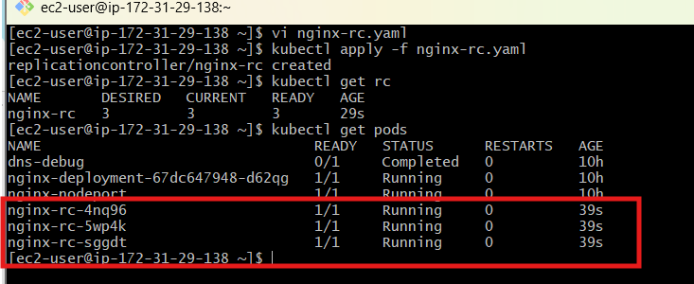

TASK 4 — Scale ReplicationController 3 → 5
Currently:
3 Pods
We want:
5 Pods
Run:
kubectl scale rc nginx-rc --replicas=5
Verify:
kubectl get rc
Expected:
nginx-rc 5 5 5
And:
kubectl get pods
You should see 5 pods.
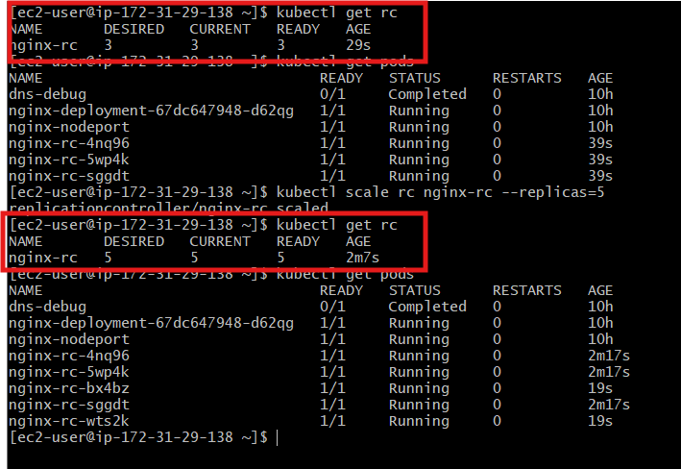

Alternative — Modify YAML
You can also change:
replicas: 3
to:
replicas: 5
Then:
kubectl apply -f nginx-rc.yaml

TASK 5 — ReplicaSet Based on Multiple Labels
Now we'll learn ReplicaSet selectors.
We want a ReplicaSet to manage pods with:
environment=prod
OR:
environment=test
Important: ReplicaSet's modern selector syntax can use matchExpressions.

Step 1 — Create ReplicaSet
vi nginx-rs-multiple-labels.yaml
Add:
apiVersion: apps/v1
kind: ReplicaSet
metadata:
name: nginx-multi-rs
spec:
replicas: 3

selector:
matchExpressions:
- key: environment
operator: In
values:
- prod
- test

template:
metadata:
labels:
app: nginx
environment: prod
spec:
containers:
- name: nginx
image: nginx
ports:
- containerPort: 80
Apply:
kubectl apply -f nginx-rs-multiple-labels.yaml

Step 2 — Verify
kubectl get rs
Then:
kubectl get pods --show-labels
You'll see something like:
nginx-multi-rs-xxxxx 1/1 Running ... app=nginx,environment=prod
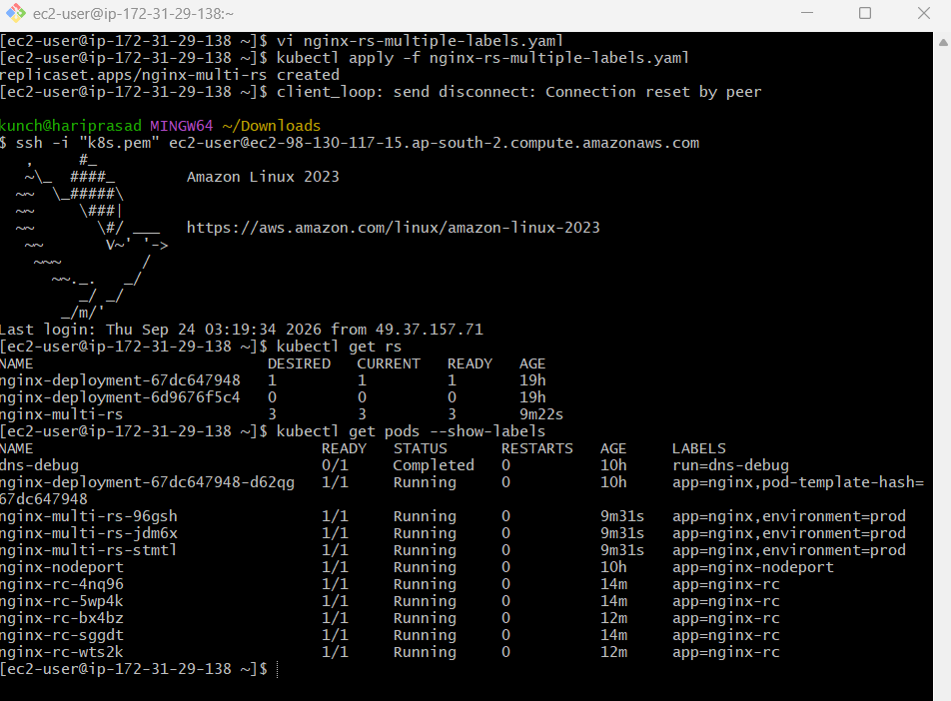
Important interview point
This selector:
operator: In
values:
- prod
- test
means:
environment = prod
OR
environment = test

TASK 6 — ReplicaSet Excluding Pods with backend Label
Now we want a ReplicaSet that does NOT select pods where:
tier=backend
We'll use:
operator: NotIn

Step 1 — Create ReplicaSet
vi nginx-exclude-backend.yaml
Add:
apiVersion: apps/v1
kind: ReplicaSet
metadata:
name: nginx-no-backend-rs
spec:
replicas: 3

selector:
matchExpressions:
- key: tier
operator: NotIn
values:
- backend

template:
metadata:
labels:
app: nginx-no-backend
tier: frontend
spec:
containers:
- name: nginx
image: nginx
ports:
- containerPort: 80
Apply:
kubectl apply -f nginx-exclude-backend.yaml

Step 2 — Verify
kubectl get rs
And:
kubectl get pods --show-labels
Our pods have:
tier=frontend
and therefore they are selected.

Interview concept
operator: NotIn
values:
- backend
means:
tier != backend
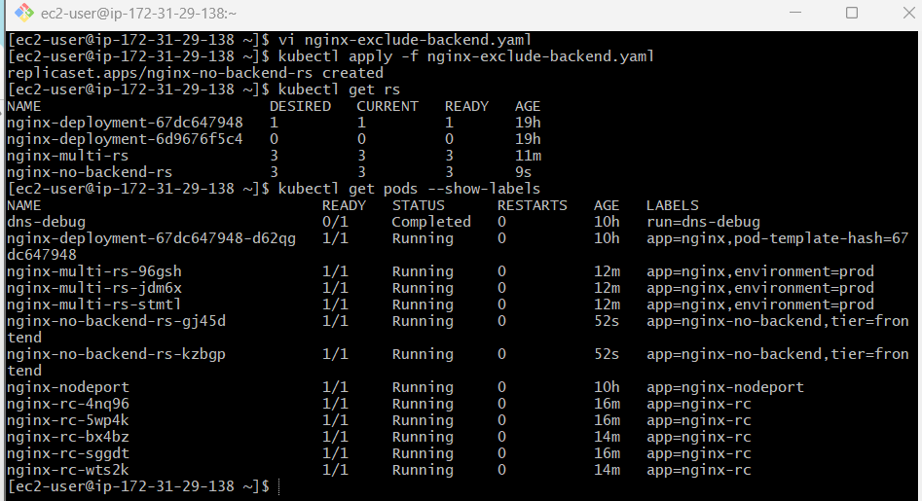

TASK 7 — Test Load Balancing Across Multiple Pods Using NodePort
This is an important practical Kubernetes exercise.
We'll use multiple Nginx pods behind a Service.
Architecture:
NodePort
|
v
Nginx Service
/ | \
/ | \
Pod1 Pod2 Pod3

Step 1 — Create Deployment
vi nginx-loadbalance.yaml
Add:
apiVersion: apps/v1
kind: Deployment
metadata:
name: nginx-lb
spec:
replicas: 3
selector:
matchLabels:
app: nginx-lb
template:
metadata:
labels:
app: nginx-lb
spec:
containers:
- name: nginx
image: nginx
ports:
- containerPort: 80
Apply:
kubectl apply -f nginx-loadbalance.yaml
Check:
kubectl get pods -l app=nginx-lb -o wide

Step 2 — Create NodePort Service
vi nginx-lb-service.yaml
Add:
apiVersion: v1
kind: Service
metadata:
name: nginx-lb-service
spec:
type: NodePort
selector:
app: nginx-lb
ports:
- port: 80
targetPort: 80
nodePort: 30081
Apply:
kubectl apply -f nginx-lb-service.yaml
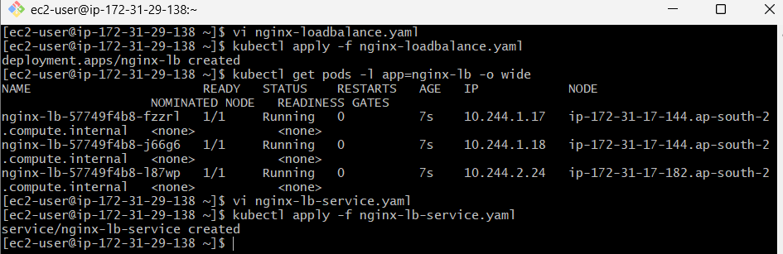

Step 3 — Check Service
kubectl get svc nginx-lb-service
You should see:
80:30081/TCP

Step 4 — Check Endpoints
kubectl get endpoints nginx-lb-service
You should see 3 pod IPs.
Example:
10.244.1.5:80,10.244.2.7:80,10.244.1.8:80
This confirms the Service knows about the 3 pods.
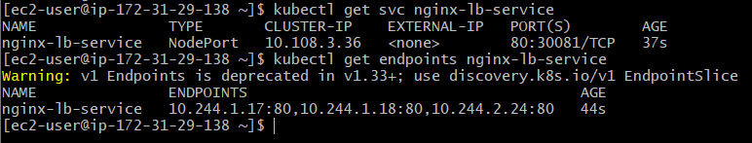

Step 5 — Test
From your browser:
http://<EC2-PUBLIC-IP>:30081
You should get:
Welcome to nginx!
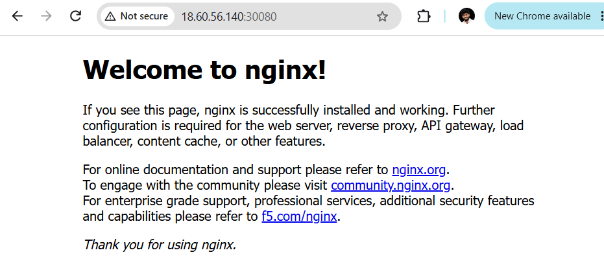
You can also test repeatedly:
curl http://<EC2-PUBLIC-IP>:30081
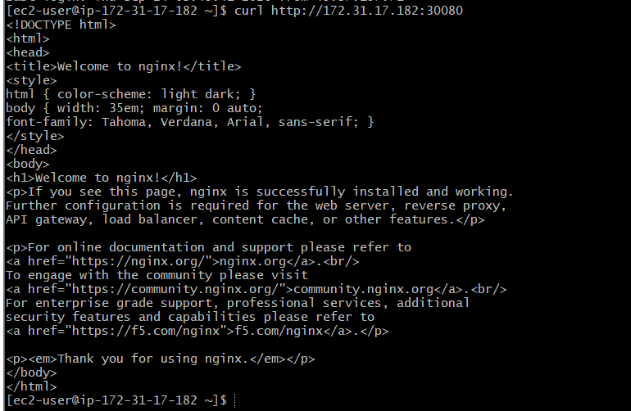
The Service distributes requests across the available backend pods.
Better practical test
To make each pod return a different response, you can modify each Nginx pod's response, but for a basic lab the important thing to verify is:
kubectl get endpoints nginx-lb-service
and confirm there are 3 backend pod IPs.

TASK 8 — Delete ReplicationController Without Deleting Pods
Step 1 — Create the ReplicationController
Create the YAML:
vi nginx-rc.yaml
Paste:
apiVersion: v1
kind: ReplicationController
metadata:
name: nginx-rc
spec:
replicas: 5
selector:
app: nginx-rc
template:
metadata:
labels:
app: nginx-rc
tier: backend
spec:
containers:
- name: nginx
image: nginx
ports:
- containerPort: 80
Save:
ESC
:wq
ENTER

Step 2 — Create the RC
kubectl apply -f nginx-rc.yaml
Expected:
replicationcontroller/nginx-rc created
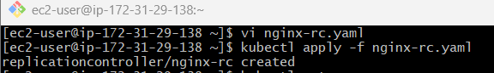

Step 3 — Verify the RC
kubectl get rc
Expected:
NAME DESIRED CURRENT READY
nginx-rc 5 5 5

Step 4 — Verify the 5 Pods
kubectl get pods -l app=nginx-rc -o wide
You should see:
nginx-xxxxx 1/1 Running
nginx-xxxxx 1/1 Running
nginx-xxxxx 1/1 Running
nginx-xxxxx 1/1 Running
nginx-xxxxx 1/1 Running
So we have:
RC = 1
Pods = 5
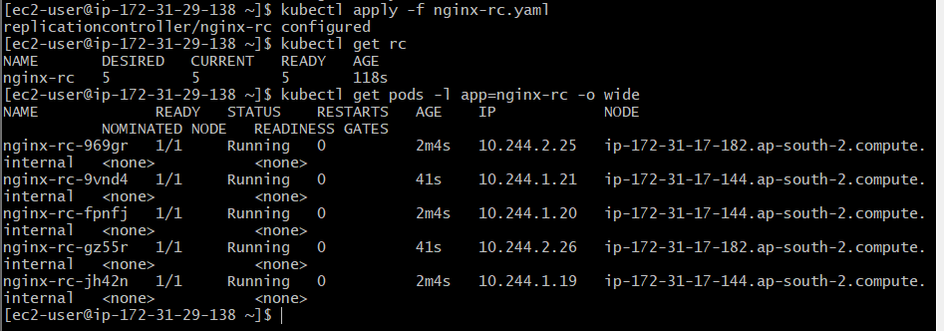

⭐ Step 5 — Delete RC but KEEP Pods
This is the actual task.
Run:
kubectl delete rc nginx-rc --cascade=orphan
Expected:
replicationcontroller "nginx-rc" deleted
The important part is:
--cascade=orphan
It means:
Delete the ReplicationController, but do not delete the Pods that it created.

Step 6 — Verify RC is gone
kubectl get rc
Expected:
No resources found in default namespace.
✅ RC deleted.
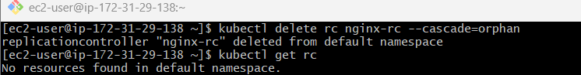

Step 7 — Verify Pods are still running
kubectl get pods -l app=nginx-rc
Expected:
NAME READY STATUS
nginx-xxxxx 1/1 Running
nginx-xxxxx 1/1 Running
nginx-xxxxx 1/1 Running
nginx-xxxxx 1/1 Running
nginx-xxxxx 1/1 Running
✅ 5 Pods are still running.
